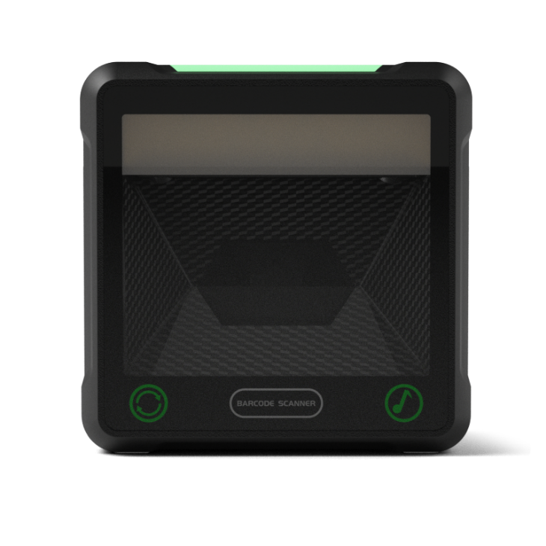
IBC-X21/ IBC-X21L
High-speed 2D scanning platform
Features:
- Equipped with a new global exposure scan engine
- Larger scanning window for easier reading
- Adjustable angle, flexible and easy to use
- Commonly used function buttons, easier to set
- 5 styles of beeps, soft and bright LED indicators
- Rich interfaces, strong compatibility, support a variety of systems and cash registers

IBC-X21/ IBC-X21L technical parameters
Physical parameters
Scan mode | Auto-sensing/continuous scanning
Communication interface | USB-HID keyboard, USB-COM virtual serial port, RS232 serial port (optional).
Interface type | USB TYPE-B
Prompt way | Buzzer, LED light
How it's set up | Press the button to set it, and manually scan the setting code in turn
Housing material | ABS+PC
Cable standards | Straight line 1.5m
Exterior dimensions | 155mm× 155mm× 82mm (product),  210mm× 160.5mm× 100mm (outer packing).
Weight | Net weight 464.7g, gross weight 664.2g
Performance parameters
The type of scan | CMOS global exposure
Resolution | 1280*800
Light source | 617nm red LED
Scan angle | ±70°, ±54°, 360° (left and right, front and back, rotation).
Scan rate | 120 times/second
Field of view | 48° (H) x 30° (V)
Print contrast | 20% minimum
Decode the kind | 1D: UPC-A, UPC-E0, UPC-E1, EAN-8, EAN13, Code128, GS1-128, Code39, Code32, Code93, Code11, Interleaved 2 of 5, Industrial 25, Matrix 2 of 5, Standard 25, CodaBar, MSI-plessey, GS1 Databar  2D: QR Code, Data Matrix (DM), PDF417, Maxi Code, Aztec Code, ISSN, NEC-25, COMPOSITE, support mobile screen reading
Minimum resolution | 4mil
Electrical parameters
Input voltage | DC 5V±10%
Current | Operating: 240 mA, Standby: 190 mA
Environmental parameters
Temperature | 0°C-50°C(Working);-20°C~+70°C(Storage).
Humidity | 5%-95% non-condensing

The above information is subject to change without prior notice

